TA自編題目_112下-28：(recursion)_GCD
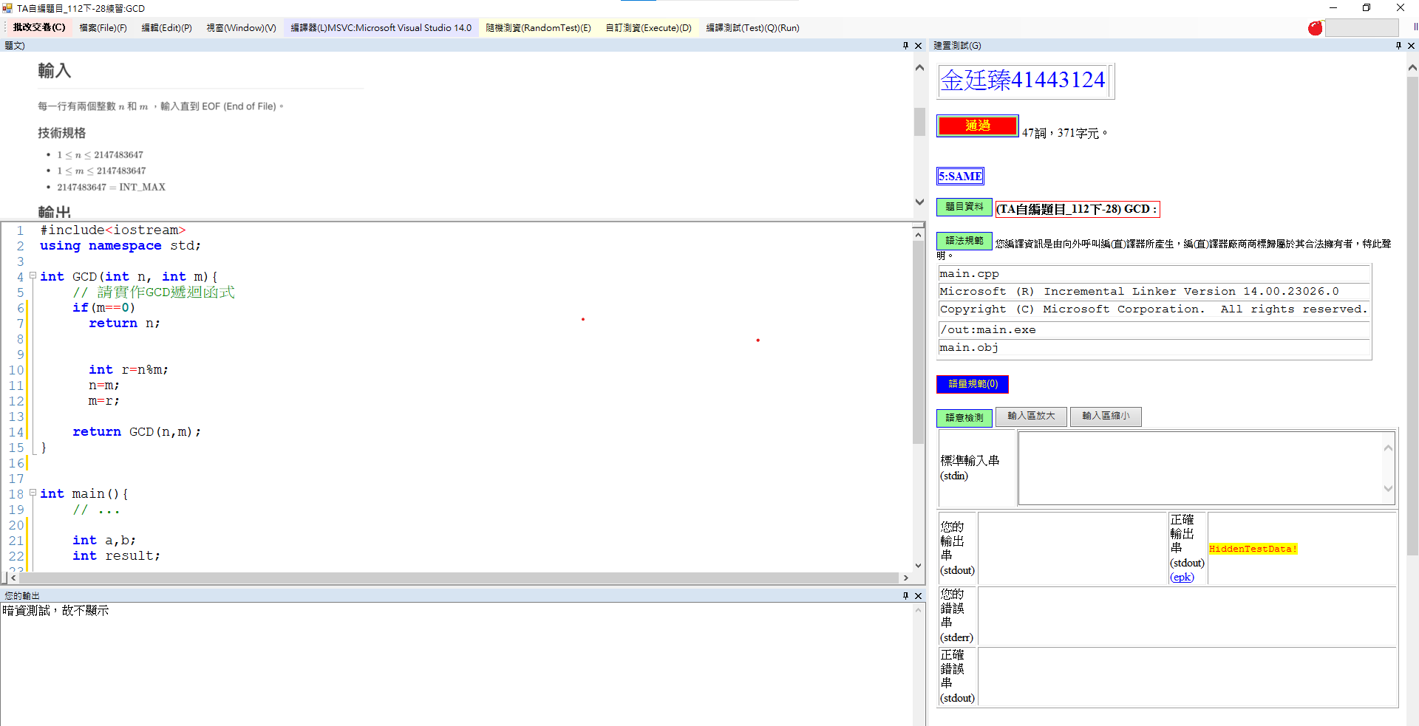
4.TA自編題目_112下-26：(binary search)_Binary Search
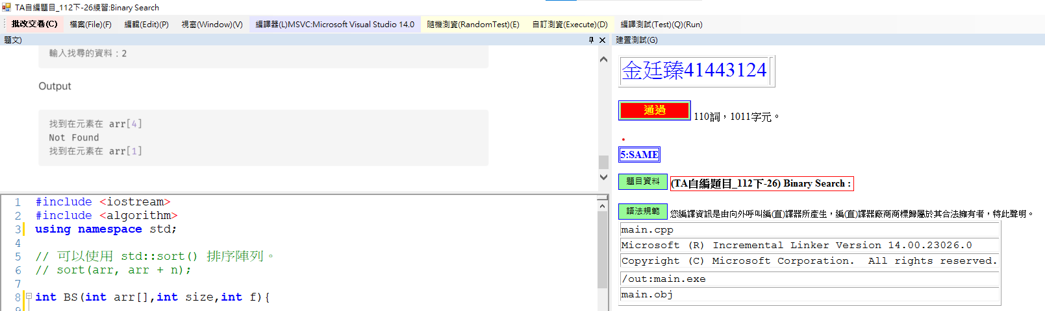
3.TA自編題目_112下-15：(recursion)_Ackermann's Function
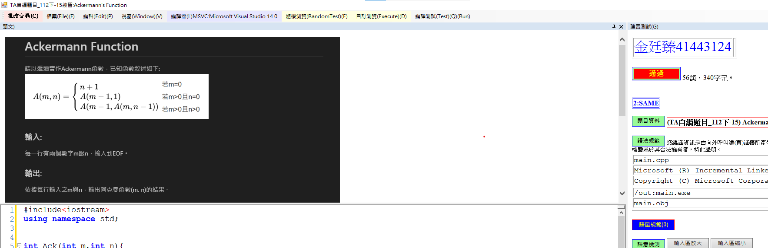
2.TA自編題目_112下-5：(pointer, array)_基本陣列操作
